**Department of Electrical Engineering and   
Computer Science**

**Faculty Member:** Dr. Shakeel Alvi **Dated:** 17/02/2022

**Semester:** 4th **Section:** BEE 12C

**EE-215:** **Electronic Devices And Circuits**

Lab 3: Characteristics & Applications of Diode

(Half Wave Rectification)

**Group Members**

|  |  |  |  |  |
| --- | --- | --- | --- | --- |
| **PLO4/CLO4** | | **PLO5/CLO5** | **PLO8/CLO6** | **PLO9/CLO7** |
| **Name** | **Reg. No** | **Viva /Quiz / Lab Performance**  **5 marks** | **Analysis of Data in Lab Report**  **5 marks** | **Modern Tool Usage**  **5 marks** | **Ethics and Safety**  **5 marks** | **Individual and Team Work**  **5 marks** |
| **Danial Ahmad** | **331388** |  |  |  |  |  |
| **Muhammad Ahmed Mohsin** | **333060** |  |  |  |  |  |
| **Muhammad Umer** | **345834** |  |  |  |  |  |
|  |  |  |  |  |  |  |
|  |  |  |  |  |  |  |

# Laboratory Experiment # 3

## Objectives

The primary purpose of this lab is to develop a working knowledge of diode. Diodes can be used in variety of circuits for various applications such as rectifiers, clippers/clampers and voltage regulators.

## Equipment

The following will be required in this lab experiment:

* PN Diode (D1N4002 or any other diode of the same family)
* Oscilloscope
* Function Generator
* Resistors (1k)
* Capacitors
* Power Supply

## Introduction

The experiment is broken down into two exercises. Each exercise has further been divided into parts. Part I involves the simulation of the circuit on PSpice using Orcad-Capture module. The second part involves the practical setup of this circuit and making required measurements, tabulation and its analysis:

## Conduct of Lab

The students are required to work in groups of four; each student must attempt to understand and use the laboratoy set-up and conduct at least one or two parts of the requirement experimentation.The lab engineer will be available to assist the students. In case some aspect of the lab experiment is not understood the students are advised to seek help from the teacher, the lab attendent or the assigned Lab Engineer.

# Exercises

## Part A (Simulation)

The first part of the experiment is to draw a graph of the I-V relationship of a diode using PSpice; this may be .accomplish by using the DC sweep analysis mode of the simulation.

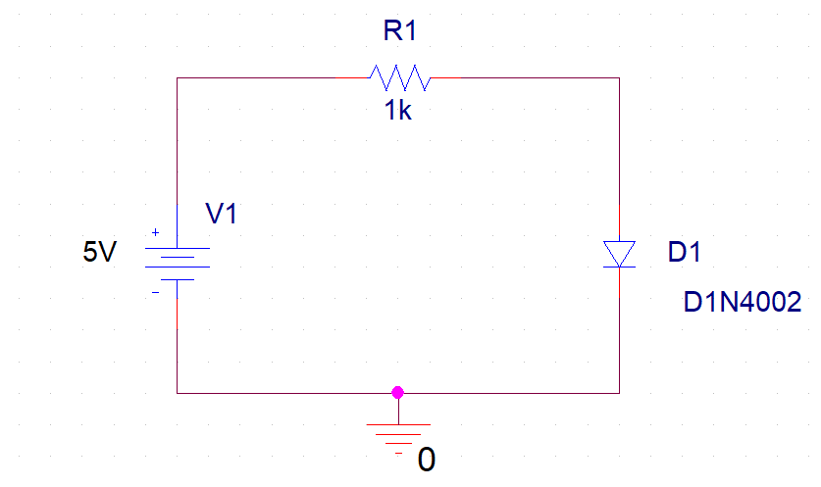

Figure 1

* Since we are analyzing a diode, we would need to draw its I-V characteristic curve. To do that, we need to simulate our circuit using DC Sweep profile settings.

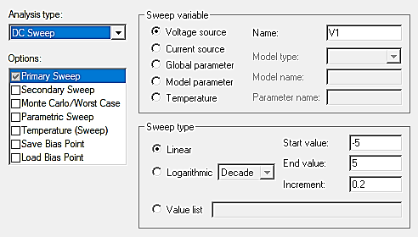

* You should make sure that the name of the voltage source is V1. If there is a different name then you should change it accordingly.
* Place the current marker/probe at the anode (upper pin) of the diode and run the simulation. Observe the plot.

**I – V Characteristic Curve: –5V to 5V**

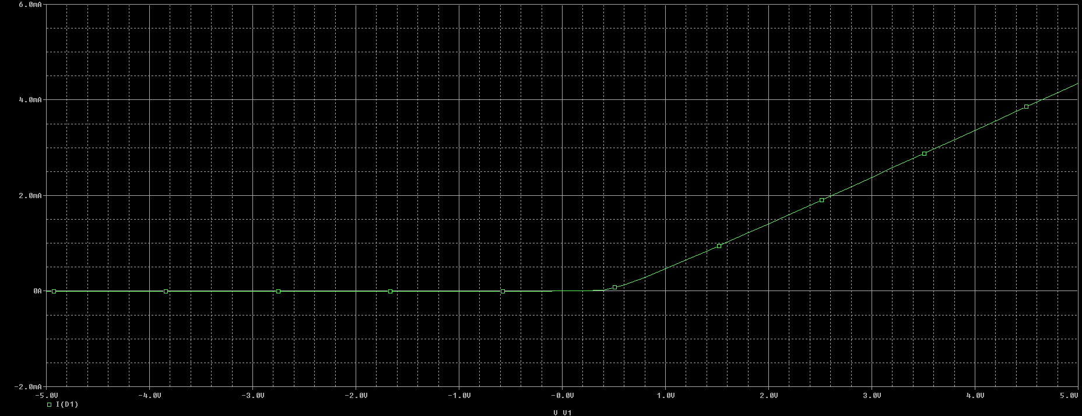

**I – V Characteristic Curve: 0.1V to 5V**

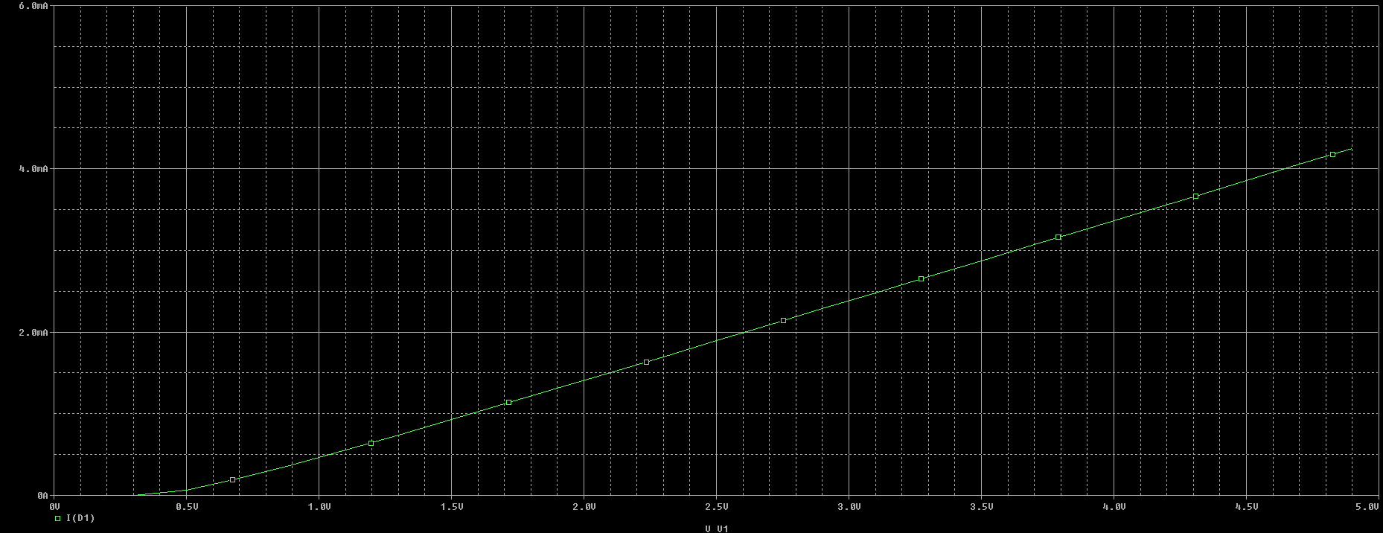

**I – V Characteristic Curve: Logarithmic Scale**

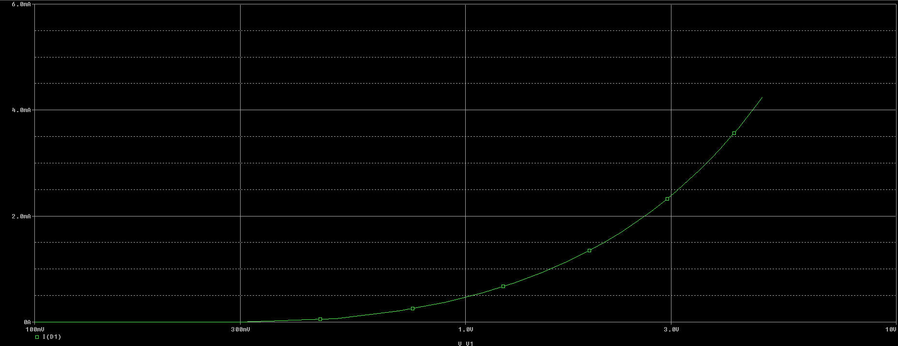

*Note: Only change the scale on the X-Axis to log this can be done by pressing the button with* ***Vertical lines****.*

**I – V Curve: Both Axis Logarithmic**

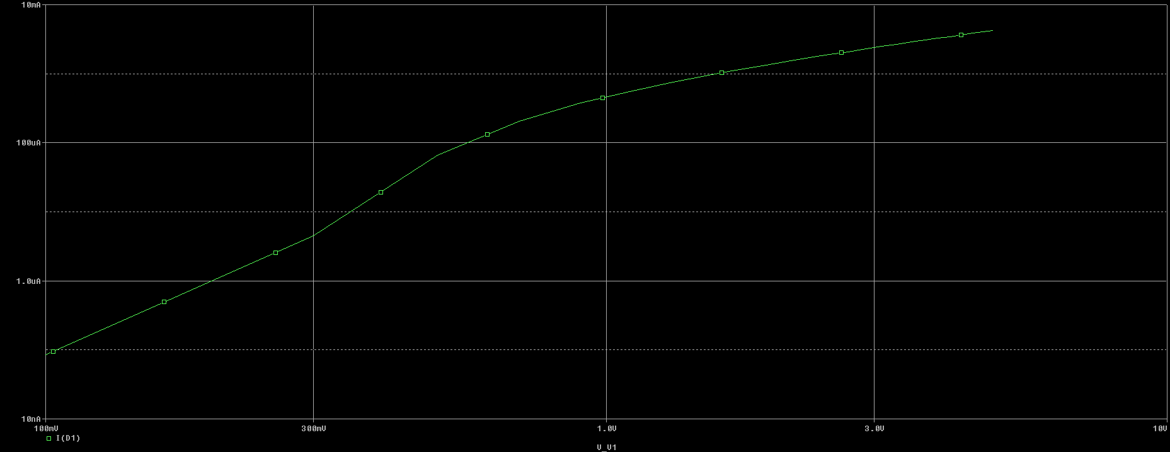

1. How can you explain the behavior of the diode by looking at the logarithmic curve?

**The diode appears to be conducting current exponentially. For the same intervals of voltage, the current grows with increasing gradient**

1. What differences do you observe in the logarithmic curve and linear curve? Which scale would help you understand the diode behavior better?

**The linear curve exemplifies the characteristics of an ideal diode whereas the logarithmic curve shows the real/exponential model of the diode. However, compared to the practical results we see that the logarithmic/exponential model better signifies the behavior.**

## Diode Resistance

Diode resistance is an important parameter of the diode.

* To observe the change in RD with reference to increasing voltage, perform the following steps:
* Simulate the circuit given in figure 1 using **linear scale** DC sweep simulation profile.

***Start Value:*** *0*

***End Value:*** *5*

***Increment:*** *0.2*

* After simulation, add traces.
* Change the X-Axis to VD or V(D1:1).
* Observe the graph obtained.

**ID – VD Curve: *Change in RD with Increasing Voltage***

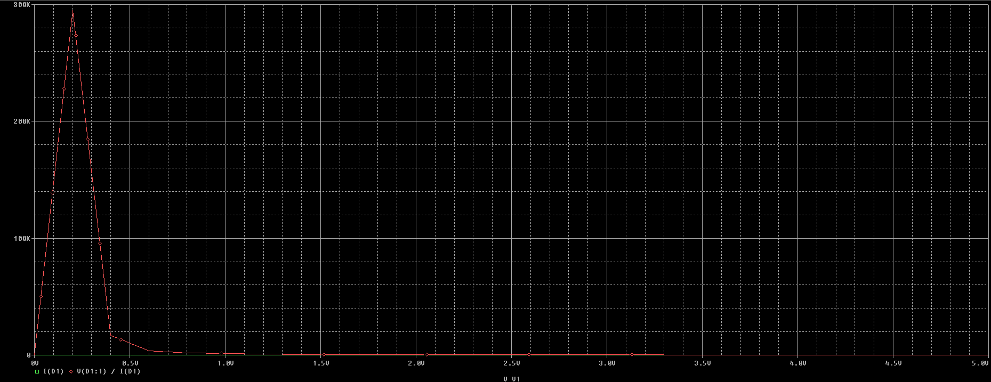

The graph that you had seen so far was between Vin and ID. Now change the x-axis variable by following, Plot → Axis Settings → Axis Variable → Select V(D1:1). This would give you the ID vs VD curve of the diode.

**ID – VD Graph: *With Changed Axis Settings***

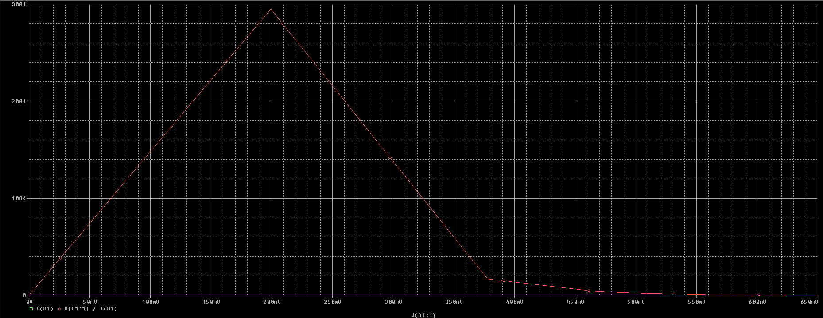

1. Spot the threshhold/cut-in voltage of the diode from the **I-V characteristic** graph? Do you think it is a silicon based diode or germanium based diode? Explain your answer.

**The threshold voltage is around 0.7 V which implies that the diode is a silicon – based diode.**

1. Explain the behaviour of RD with respect to VD as observed in the graph drawn.

**The value of RD increases linearly upto a certain voltage called the break in voltage after which the value of RD tends to decrease with increasing voltage upto the cut off voltage which is approximately 650 mV.**

## Part B (Implementation)

This part of the experiment helps the students to set a simple diode circuit and take measurements for drawing the I-V curves.

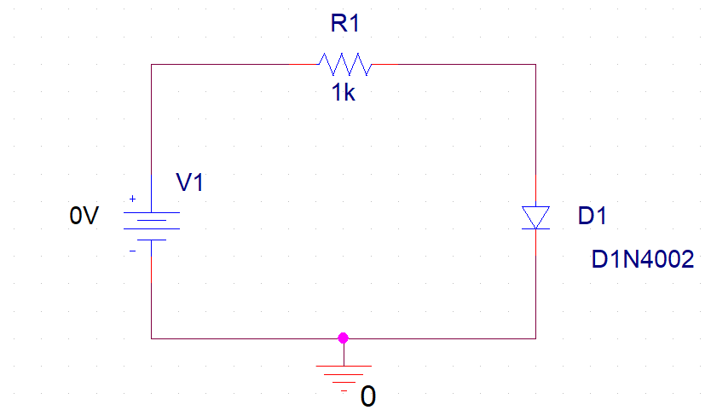

Figure 2

## Procedure

* On a breadboard, setup the circuit given as shown in figure 1.
* Apply the input voltage gradually increasing it from 0V and onwards, in steps of 0.2 volts.
* Measure and tabulate the values of ID and VD until VD becomes almost constant.

## Measurements

1. Plot ID vs VD forward characteristics using both linear scale and logarithmic scale.

|  |  |  |
| --- | --- | --- |
| VO (V) | ID (A) | VD (V) |
| 0 | 0 | -0.117 |
| 0.2 | 13.22 µ | 0.265 |
| 0.4 | 14.43 µ | 0.432 |
| 0.6 | 91.5 µ | 0.486 |
| 0.8 | 150.4 µ | 0.528 |
| 1.0 | 244.5 µ | 0.553 |
| 1.2 | 347.2 µ | 0.567 |
| 1.4 | 443.5 µ | 0.577 |
| 1.6 | 0.96 m | 0.585 |
| 1.8 | 1.14 m | 0.596 |
| 2.0 | 1.28 m | 0.603 |
| 2.2 | 1.50 m | 0.607 |
| 2.4 | 1.67 m | 0.614 |
| 2.6 | 1.81 m | 0.618 |
| 2.8 | 2.00 m | 0.623 |
| 3.0 | 2.18 m | 0.627 |
| 3.2 | 2.37 m | 0.631 |
| 3.4 | 2.51 m | 0.635 |
| 3.6 | 2.72 m | 0.638 |
| 3.8 | 2.88 m | 0.640 |
| 4.0 | 3.06 m | 0.643 |
| 4.2 | 3.27 m | 0.646 |
| 4.4 | 3.39 m | 0.649 |
| 4.6 | 3.60 m | 0.651 |
| 4.8 | 3.73 m | 0.653 |
| 5.0 | 3.98 m | 0.655 |

# Exercise – II

## Part C (Half – Wave Rectification)

**Procedure**

Set up the circuits given in the following figure. Apply 10 volt peak sine wave as an input signal and see the output signal across the 1K Resistor, on oscilloscope for both, forward bias and reverse bias circuits.

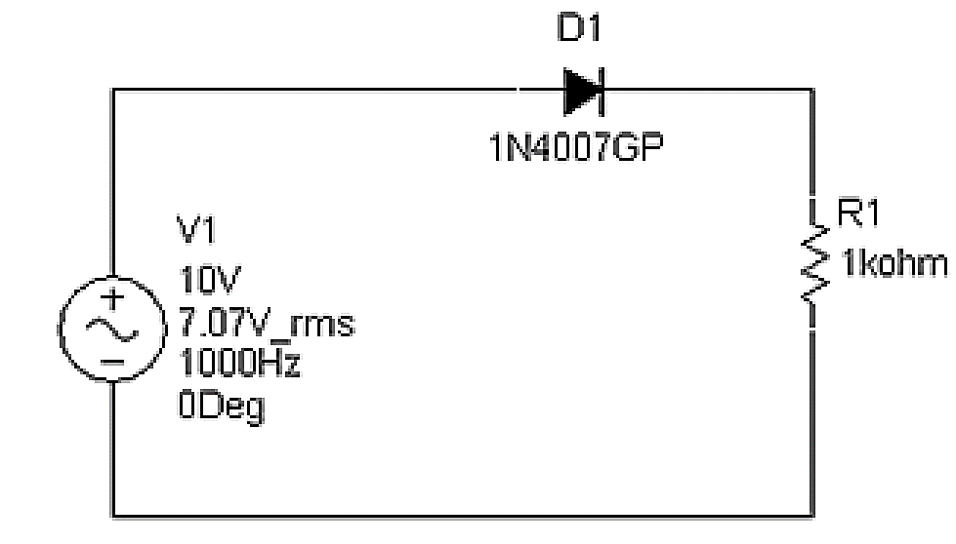

**Circuits for Half-Wave Rectifiers**

**Observations**

1. Observe the Input and output waveforms on a dual trace oscilloscope. What differences are observed between input and output waveforms and why?

**Forward Bias**

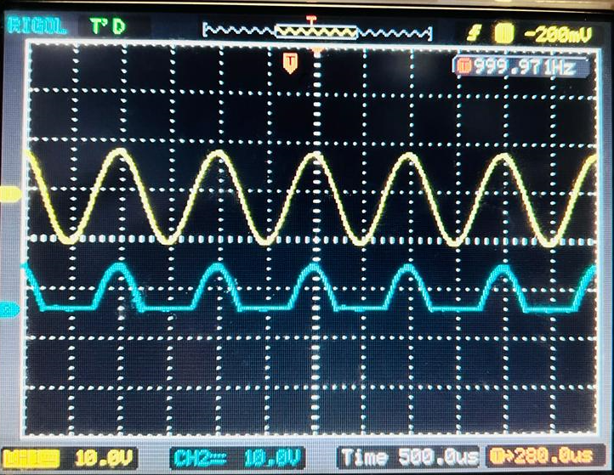

**Yellow: Input – Blue: Output**

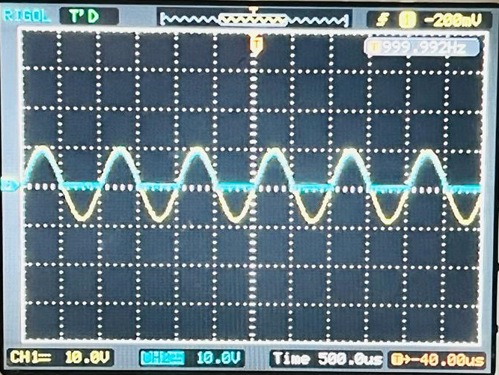

**Superimposed**

The input wave is a pure sinusoidal wave whereas the output wave has underwent the process of half – wave rectification due to the presence of diode.

**Reverse Bias**

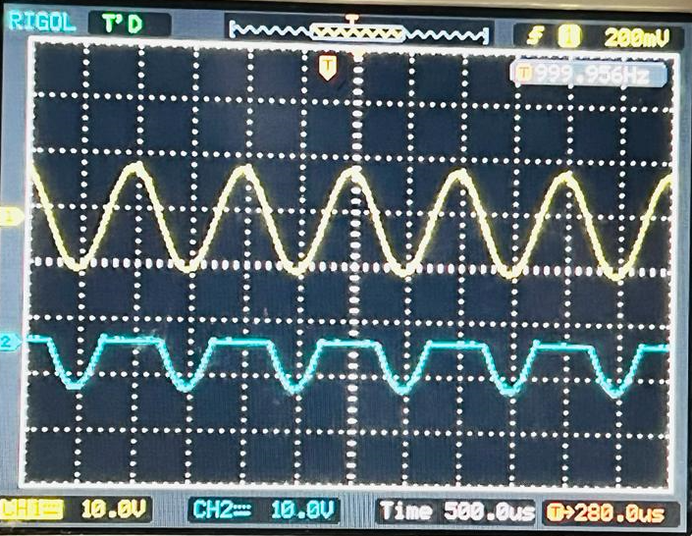

**Yellow: Input – Blue: Output**

Unlike forward rectification, reverse rectification rectifies the positive peaks and hence the output waveform is reverse.

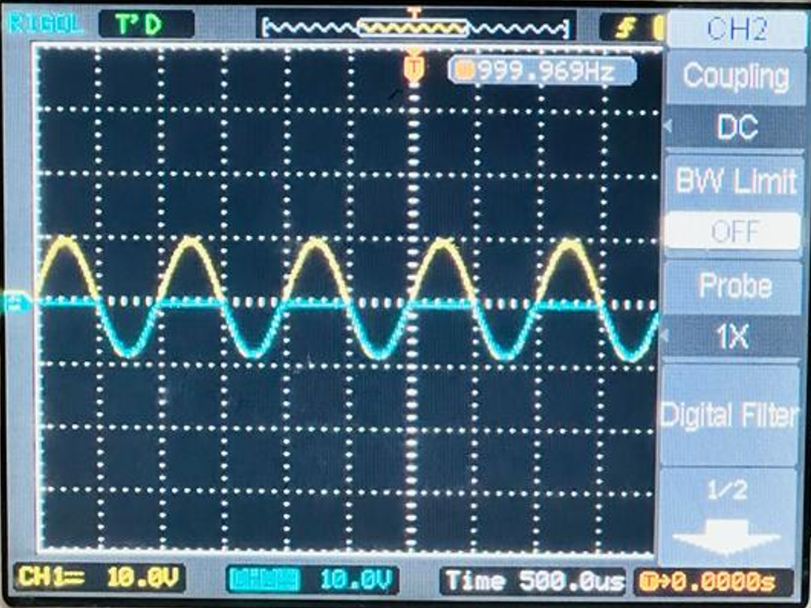

**Superimposed**

1. If we were to use two diodes in series, how would that affect the output of the circuit? Explain.

When two diodes are used in series, there are three different possibilities.

1. **Both are Forward Bias**, and hence the net-voltage drop is 2 times the cut-in voltage; 2 x 0.7 V = 1.4 V for Silicon diodes. We observe this voltage drop in a manner that our signal in blue has a lower peak than when we used a single diode.

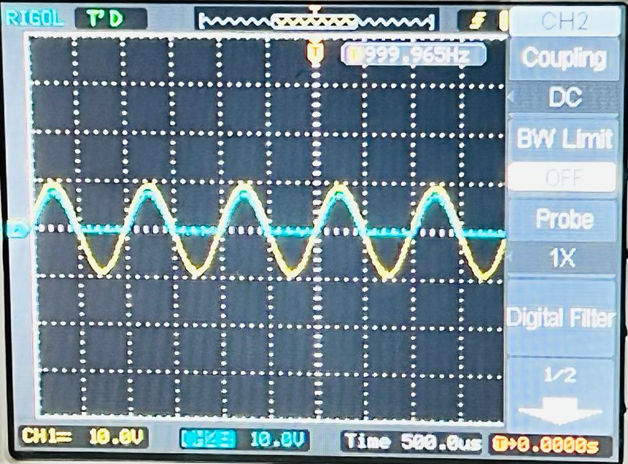

**Forward Bias**

1. **Both are Reverse Bias**, and hence the net-voltage drop is 2 times the cut-in voltage; 2 x - 0.7 V = - 1.4 V for Silicon diodes. It is the same as when both were forward bias, just in the opposite direction.

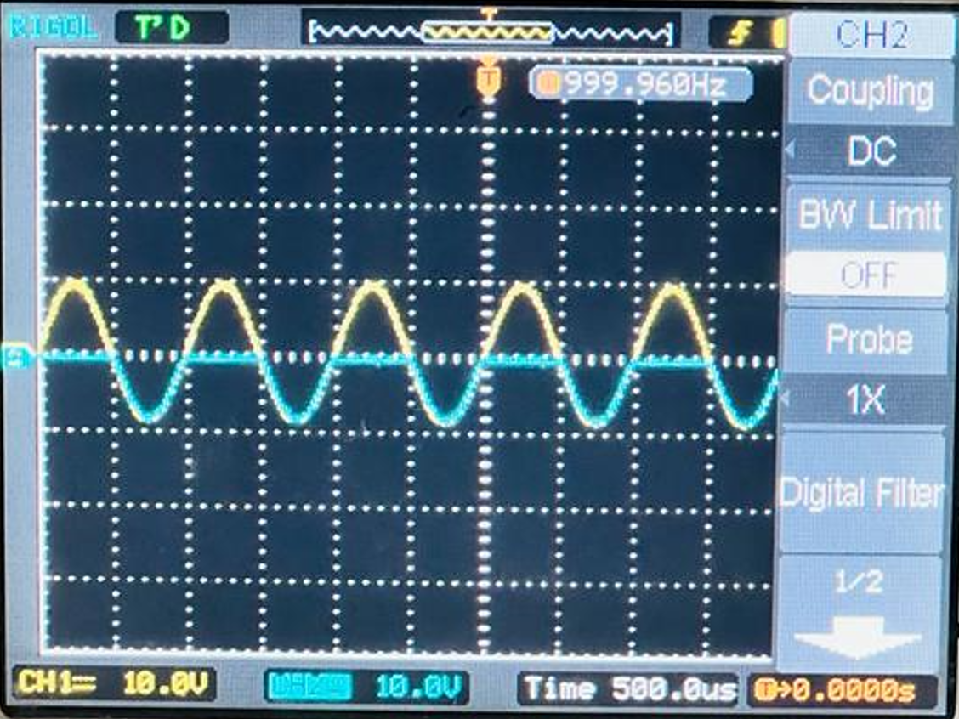

**Reverse Bias**

1. **One is Forward Bias and the Other is Reverse Bias**, in which case the voltage across the resistor would be a straight line as both the diodes cancel the effect of each other, resulting in zero voltage at the output.

## Conclusion

After performing this lab, we have achieved the following goals;

* A fundamental component of electronic circuits, a diode
* Studied the behavior of diode in presence of AC and DC power sources
* Studied the relation of ID, VD, and RD among each other through plotting out relevant characteristic curves
* Familiarized ourselves with half-wave rectification property of diodes